Game Design Document

Space Escape

Genre: Sci-fi, Action Adventure

Target Audience: Sci-fi enthusiasts,   
teens and young adults who enjoy action-based games.

Developer: Abigail Sutton

Date: 16/5/2025

Table of Contents

Introduction: 3

Overview 3

Game Rules and Mechanics: 3

Core Gameplay Loop: 3

Progression: 4

Game Structure: 4

Player Journey: 4

Control Scheme: 4

User Interface Design: 5

Mock Interface and Sample Screens: 5

Key Algorithms: 5

Cheat Features: 6

Required Asset List: 6

Look and Feel: 7

Bibliography: 7

## Introduction:

Space escape is a retro-style, pixel art, action-adventure game set in a mysterious universe of hostile alien planets. Players are trapped in a black hole rift and must gather rift vials and ship parts to rebuild their spaceship and escape. Space escape combines the arcade style with modern sci-fi and features permadeath mechanics, intense combat, unique planet effects, and a nostalgic visual and audio design.

## Overview

Players begin with a broken spaceship and no way back, forced to enter alien planets in search of resources. Each planet brings new dangers and mechanics. With only three lives and no checkpoints, players must master fast-paced combat and strategic movement.

Objectives:

* Explore alien planets
* Collect rift vials and ship parts.
* Survive with limited lives
* Escape the rift by repairing the ship

## Game Rules and Mechanics:

1. Players only have three lives. Once all lives are lost, the game ends and restarts from the beginning.
2. All combat includes melee and ranged weapons.
3. Rift vials open a new black hole rift for the player to unlock the next planet.
4. Ship parts must be collected to rebuild the ship.
5. Bosses that spawn can drop rare weapons.
6. Effects from each planet will modify the gameplay, e.g. reverse controls, slow time.

## Core Gameplay Loop:

In Space Escape, the game loop consists of these:

1. Land on the planet vial the black hole rift.
2. Eliminate all aliens on the planet.
3. Collect the required items – vials and parts.
4. Upgrade weapons if dropped by the bosses.
5. Travel through the rift again to the next planet.

## Progression:

Space escape features dynamic progression, with planets unlocked one by one and difficulty increasing with each new planet. Weapons dropped by bosses provide permanent weapon upgrades for the rest of the run. Replay ability is supported by random boss spawns and weapon drops, making each run unique.

## Game Structure:

Space escape will have a mission based linear structure. Each mission is a different planet with unique effects, and the final level will feature the boss holding the final three ship parts and rift vial.

## Player Journey:

Start: Basic knife and a broken ship.

Mid-game: Upgraded weapons, rising tension.

End-game: Boss battle and ship repair.

Finish: Escape the rift.

## Control Scheme:

Keyboard:

Move: W/A/S/D and Arrow keys

Attack: Left click

Interact: E

Pause: ESC

Console (Xbox controller):

Move: D pad

Attack: X

Interact: Y

Pause: Menu

Navigation: D pad, B

## User Interface Design:

Space escape will use a simplistic and universal UI design to ensure simplicity and familiarity with players.

Top Left: Health bar, Collected items.

Top Right: Current weapon.

Bottom Centre: Lives remaining.

Start of planet: Popup of environmental effect.

## Mock Interface and Sample Screens:

Main menu: New game, difficulty selection, settings:

In-game HUD: Minimal retro style overlay with indicators for weapons, health, and items:

Planet screen: Top-down view with pixel art terrain, enemies, and items:

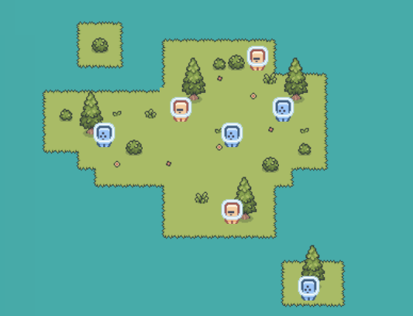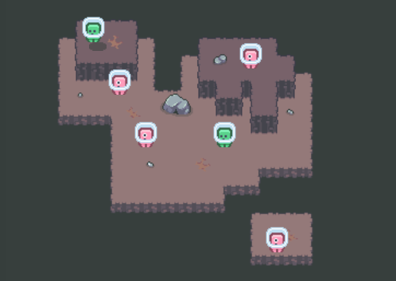

Game Over screen: “Lost in the rift. Try Again?” – Timed Scene:

## Key Algorithms:

Enemy spawning: Random generation based on planet level.

Boss Spawn chance: Random percentage (10%).

Planet effect selector: Random planet modifier per level.

Life tracker: On life loss, restart current level. On 0 lives left, full game reset.

Player Spin algorithm: Turn the character around the rift portal in the center of the screen.

## Cheat Features:

Dev mode within Space Escape unlocks several features to test out the game:

* Invincibility
* Unlocks all weapons and can select the current weapon.
* Can skip all planets to the final boss.

## Required Asset List:

Sprites:

* Player animations (walk, idle, attack)
* Alien types (3 variations)
* Boss designs (2 bosses)
* Environmental tile-sets (3 planet types)
* Item sprites (Vials, weapons, ship parts)
* Spaceship sprite

Animations:

* Weapon attack animations
* Explosion and damage effects
* Black hole rift animations.
* Planet-specific transitions.

Audio:

* Background music for menu and planets
* Combat and item pickup sound effects

## Look and Feel:

Visual Style: Retro pixel art, 8/16 bit

Mood: Intense, mysterious, adventurous.

Audio: Arcade style effects, Syth music.

## Bibliography: